**NE 591-010: Fuel Performance**

**MOOSE Project Report**

**Quentin Faure**

04/30/2021

**INTRODUCTION**

Multiphysics Object Oriented Simulation Environment (MOOSE) [1], a finite element framework, allows to model a vast number of physics problems such as heat conduction in steady-state and transient scenario. Heat conduction is one of the main physics area of fuel performance. The heat transport equation shown in Eq. 1, defines the temperature evolution in nuclear fuel.

|  |  |
| --- | --- |
|  | Eq. (1) |

By solving this equation, one can determine the temperature distribution in the fuel, gap, and cladding. In this report, simulations of the heat transport equation using MOOSE in steady-state and transient scenario for two cases are presented. The first case is a pseudo one dimensional radial problem (the axial length considered is 1 cm) with a constant volumetric heating rate and time dependent volumetric heating rate. In the second case, a two-dimensional problem very similar to the first case with the addition of a second dimension and an axial temperature variation is presented.

**“1-D” STEADY STATE**

A fuel pin is being model with a fuel radius of 0.5 cm, a gap thickness of 0.1 cm, and a cladding thickness of 0.1 cm as shown in Figure 1. The mesh selected is 140 x 100 so that in the radial dimension, the boundaries between the gap and the fuel/cladding are on a node.

**Figure 1. "1-D" model**

The thermal conductivity for the fuel (UO2), gap (He), and cladding are considered constant. They are calculated using the equations found in Ref. [2]. To determine them, a cladding temperature of 500 K was selected, 550 K for the gap temperature, and 850 K for the fuel temperature. Using these temperatures and the equations found in Ref. [2], the thermal conductivity of the fuel, gap, and cladding are respectively 0.0411 Wcm-1K-1, 0.00236 Wcm-1K-1, and 0.161 Wcm-1K-1. The volumetric/areal heating rate in the fuel is provided and is 250 Wcm-2. The boundary conditions are a constant temperature of 500 K on the outer cladding surface and symmetrical boundary at the center of the fuel ( at r = 0 cm). The initial temperature profile is set to 500 in all three regions. Using these parameters and boundary and initial conditions (BICs), the temperature profile in the middle of the fuel in steady state is determined using MOOSE (the entire model uses Kelvin and cm for units). Figure 2 shows the results obtained.

**Figure 2. Temperature profile "1-D" steady state with realistic thermal conductivities**

As seen in Figure 2, the centerline temperature is 3324 K that is too high and not realistic (UO2 melting temperature is 3138.15 K, so some parts of the fuel are melting). The reason behind this result is that the gap thickness is 0.1 cm. A normal gap thickness should in the order of 10 microns. The cladding thickness is also slightly too large compared to normal UO2 fuel (around 0.05 mm). Therefore, the results found are not realistic. However, this simulation allows us to understand how MOOSE computes the temperature in the fuel area, gap area, and cladding area. In the fuel area where the heat generation is present, the fuel temperature follows a second-degree polynomial form as expected. In the cladding and the gap, the temperature profiles follow a second-degree polynomial solution. Figure 3 shows a second-degree polynomial fitting of the temperature profile in the cladding. The maximum relative error between the temperature profile and the fitting is 2.6453E-05. Normally, a linear model for the gap and for the cladding can be used for hand calculation under the assumption that the cladding thickness and gap thickness are small and therefore that the radial variation is small. That is not the case here, therefore, the equation presented during the lectures can not be used for the cladding and the gap.

**Figure 3. Temperature profile in the cladding with a second-degree fitting curve**

In order to have more realistic results for the temperature profile, the thermal conductivity of the gap is increase by two orders of magnitude to 0.236 Wcm-1K-1 since the gap is two order of magnitude larger. Figure 4 shows the temperature profile in the middle of the fuel. As seen in Figure 4, the maximum temperature at the centerline of the fuel is 934 K. The temperature in the cladding goes from 500 K to 530 K, in the gap from 530 K to 554 K, and in the fuel from 554 K to 934 K (380 K difference). Using the Eq. 2, the maximal temperature variation in the fuel is 380 K, verifying the modeling of the problem for the fuel region. However, for the gap and cladding regions, as explained above, the verification can not be made. The temperature selected to calculate the thermal conductivities before performing the simulation are in the range of temperatures in the fuel, gap, and cladding. Therefore, they will be kept for the future simulations.

|  |  |
| --- | --- |
|  | Eq. (2) |

**Figure 4. Temperature profile "1-D" steady state with modified thermal conductivities**

**“1-D” TRANSIENT**

The prior model is modified to implement a time dependent volumetric/areal heating rate as shown in Eq. 3. The time term in the heat conduction equation (Eq. 1) is added to the model as well. The densities and heat capacities are calculated using Ref. [2] and the temperature used to calculate the thermal conductivities. The densities for the fuel, gap, and cladding are 10.78 g/cm3, 0.00422 g/cm3, and 17.8 g/cm3 respectively. For the heat capacities, they are 0.304 J/kg, 5.91 J/kg, and 0.420 J/kg respectively.

|  |  |
| --- | --- |
|  | Eq. (3) |

A simulation time of 200 s and a time-step of 1 s are selected. A PJFNK solver is selected (Preconditioned Jacobian-Free Newton Krylov). This solver has already a preconditioner implemented in it and uses the Newton-Krylow method for time dependent calculation. The centerline temperature as a function of time is shown in Figure 5. The initial temperature in the model is selected to be 500 K. Therefore, the centerline temperature starts from this value. During the first 20 seconds or so, there is a very rapid fuel temperature increase due to the initial temperature being very low. The temperature evolution after the first 20 s, seems to have a curve similar to the volumetric/areal heating rate but delayed. It is due to the heat-capacity and density that are not very high.

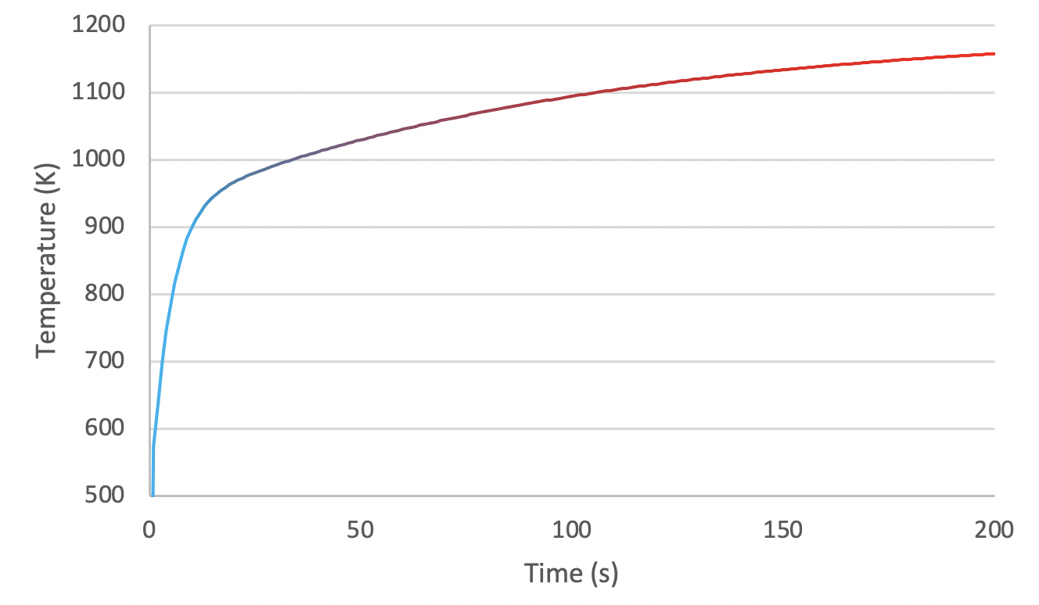**Figure 5. Centerline temperature evolution in 1-D case**

**2-D STEADY STATE**

A second model is being developed as shown in Figure 6. In this model, the axial dimension is implemented. Therefore, the quantity of axial node is scale by the same factor here (140 x 100 nodes for the “1-D” case, 140 x 10,000 nodes here). Another modification from the prior model is the implementation of an axial temperature profile for the coolant. Eq. 4 shows how the axial dependency of the coolant temperature is being calculated. The Linear Heating Rate (LHR) is considered independent of the axial position. The solution to Eq. 4 is presented in Eq. 5. The coolant temperature at z = 0 cm is taken to be 500 K. and are taken to be 0.25 kg/s-rod and 4200 J/kgK. In Eq. 5, the LHR is in W/cm and z in cm. Therefore, the volumetric/areal heating rate, constant at 250 W/cm2, needs to be multiplied by the radius of the fuel (0.5 cm) in order to be converted in W/cm. Therefore, the axial variation of the coolant temperature is implemented as in Eq. 6 in the MOOSE model. The total axial variation is therefore 11.9 K. For a fuel rod of 3.6 m long, the total coolant variation would be 42.9 K that seems reasonable. Therefore, the mass flow rate and coolant specific heat selected are kept.

**Figure 6. 2-D model**

|  |  |
| --- | --- |
|  | Eq. (4) |
|  | Eq. (5) |
|  | Eq. (6) |

Figure 7 shows the temperature profiles at different axial elevations (25 cm, 50 cm, and 1 m). A small difference between each axial profile can be seen because the axial coolant variation is very small. A difference with the “1-D” case is that here the boundary condition is applied on the coolant far enough that the fuel heating does not impact it (i.e. at an infinity distance). Therefore, the temperature at the outer surface of the cladding is not 500 K as we saw in the “1-D” case where the boundary condition was applied at the cladding outer surface. The temperature variation at 0.25 m, 0.5 m, and 1 m are 521 K to 955 K, 524 K to 958 K, 530 K to 964 K respectively. The difference in temperature between each profile remains constant though the entire fuel, gap, and cladding as expected since the volumetric/areal heating rate remains constant and only the axial coolant temperature changes. The temperature variation in the fuel is the same as for the first case (380 K) since the volumetric/areal heating rate is the same. But the temperatures in the fuel, gap, and cladding are higher due to the boundary condition is on the coolant temperature far from the fuel and not on the cladding. The small variation between each axial profile is explained by the small variation in the coolant temperature.

**Figure 7. Temperature profile at: (a) z = 0.25m, (b) z = 0.5 m, (c) z = 1 m, (d) combined**

**2-D TRANSIENT**

The 2-D model is modified to implement a time dependent volumetric/areal heating rate and time term of Eq. 1. The new volumetric/areal heating rate is the same as in Eq. 2. Due to the high number of nodes (140 x 10,000) used for the 2-D models, the simulations are time consuming. Therefore, for the transient simulation here, the number of nodes is reduced to 140 x 200 only. Figure 8 shows the centerline temperature as function of time at z = 0.25, z = 0.5 m, and z = 1 m. As expected, the temporal evolution at each elevation is almost same. There is a rapid increase in the fuel temperature at the beginning of the simulation, similar to the 1-D case, because the initial temperature in the fuel is 500 K. Figure 9 shows the centerline temperature at a time of 200 s as a function of the axial position. The maximum temperature is found at z = 1 m and is 1198.5 K. In a reactor, the volumetric/areal heating rate is not axially constant and can have a shape close to a cosine. Therefore, the axial fuel centerline temperature is not linear, and the maximum is not at the top of the rod contrary to what is seen here. The centerline axial temperature variation between the top and the bottom of the rod is 11.8 K that is very closed to the coolant total axial variation (11.9 K).

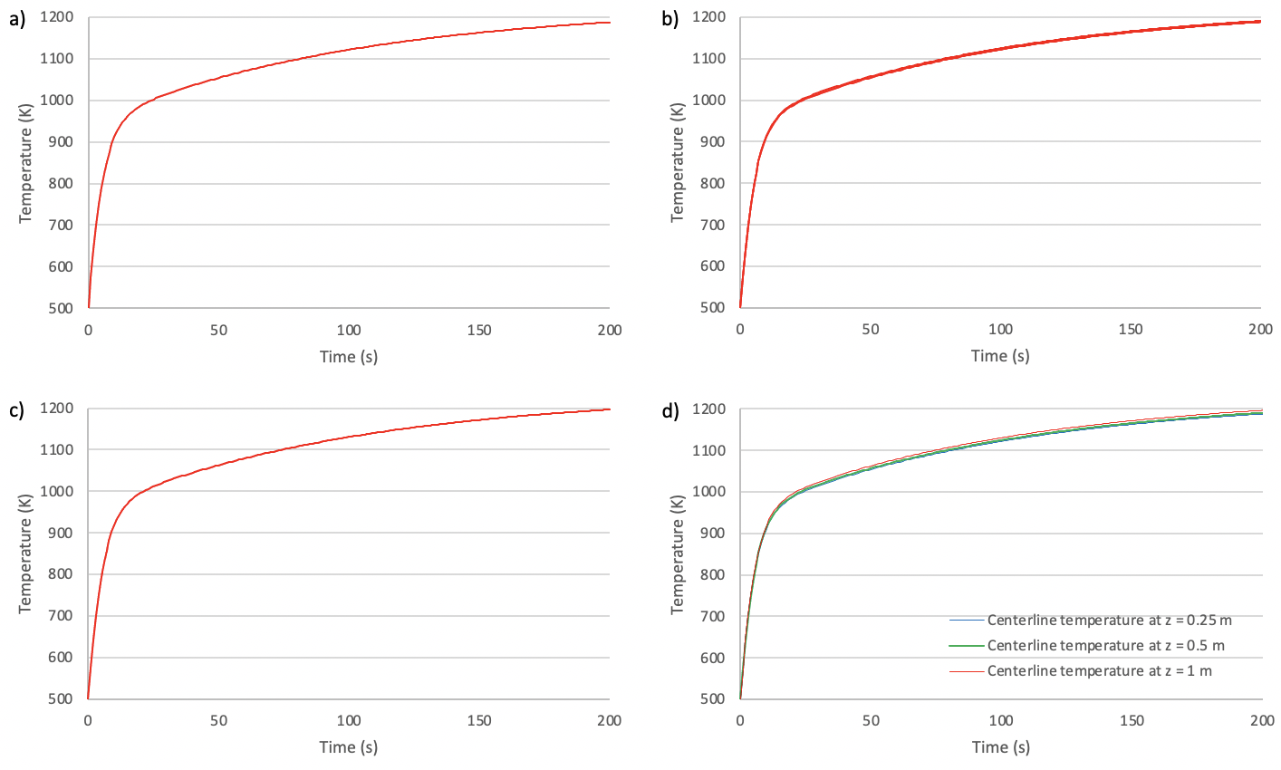

**Figure 8. Centerline temperature evolution at: (a) z = 0.25m, (b) z = 0.5 m, (c) z = 1 m, (d) combined**

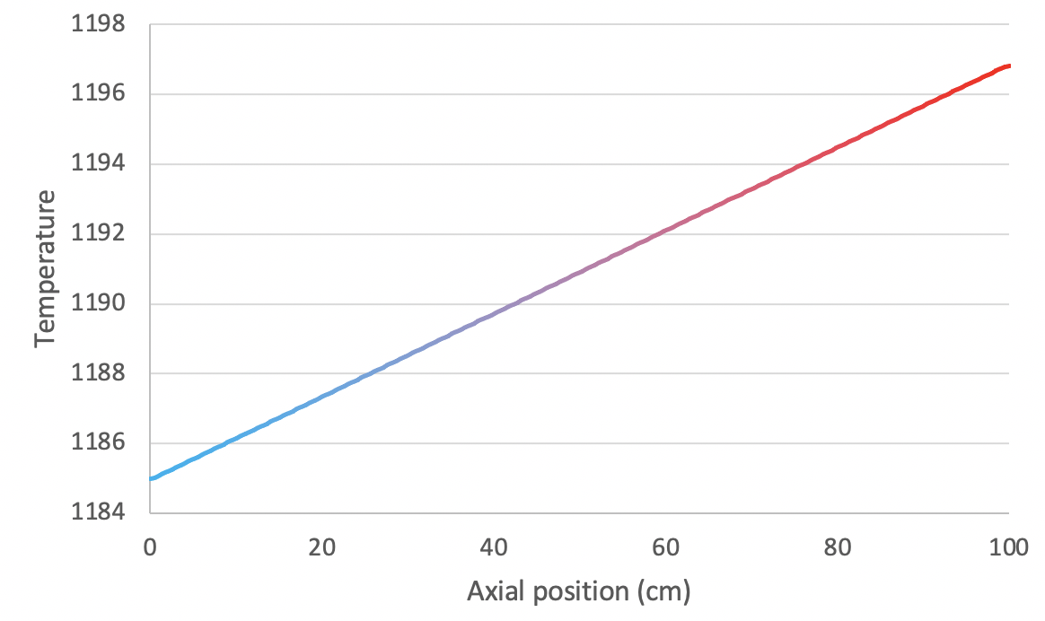

**Figure 9. Centerline temperature as a function of the axial position**

**CONCLUSION**

Using MOOSE, a “1-D” and 2-D models of fuel pin are created in steady state and transient scenario. Due to the nonrealistic dimension of the model, modified thermal conductivities have been selected in order to have realistic solutions. MOOSE solution for the temperature profile in steady state are second-degree polynomial that are exact solution to the cases studied here. In transient scenario, the PJFNK solver is selected. The temperature sharply increases at the beginning of the simulation due to the low initial temperature of 500 K. The temperature profiles in the fuel are very similar one from the other due to the small coolant axial temperature variation.

**REFERENCE**

[1] Gaston D., Newman C., Hansen G., Lebrun-Grandie D., “*MOOSE: A Parallel Computational Framework For Coupled Systems Of Nonlinear Equations”,* Nucl Eng Des, Vol. 239 (10), 2009, pp. 1768-1778

[2] Newman C., Hansen G., Gaston D., “*Three Dimensional Coupled Simulation Of Thermomechanics, Heat, And Oxygen Diffusion In UO2 Nuclear Fuel Rods*”, Journal of Nuclear Materials, Vol. 392 (1), July 2009, pp. 6-15**.**